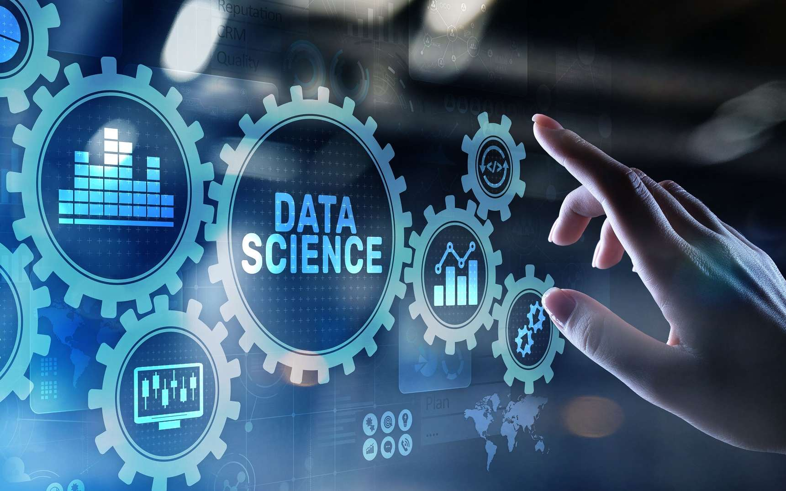

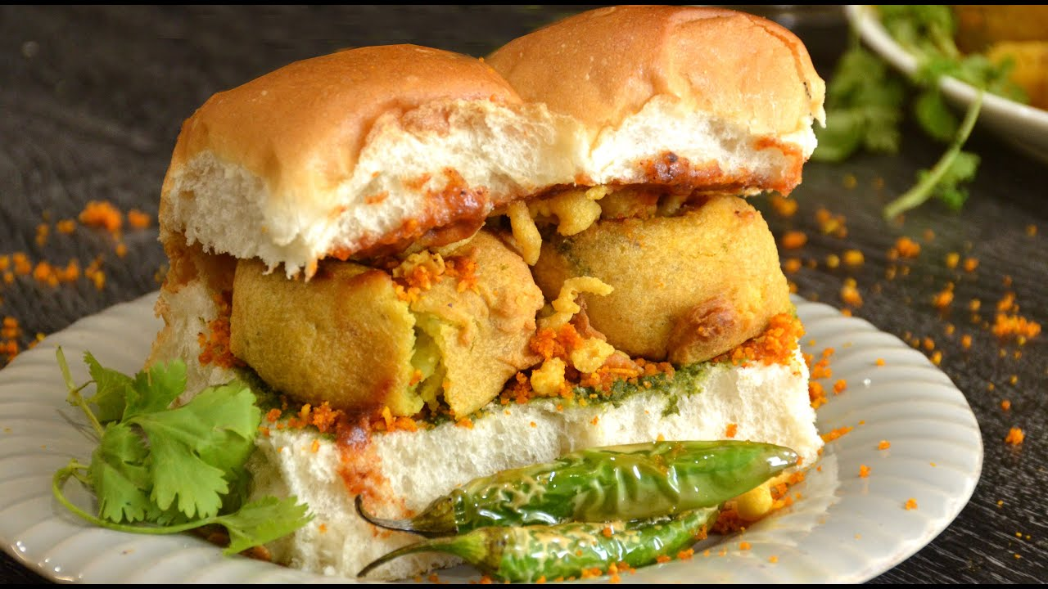

***DATA SCIENCE USE IN STARTUP BUSINESS***

***--COLLECTING DATA FROM DIFF SOURCES***



Agenda

* Introduction
* Problem Statement and Data Source
* Objective & Methodology
* Solution Description
* Impact

Introduction

This PPT is represents the key points in starting new startup. Our client wants to start vada pav business in Shivaji Nagar, Pune. But, the place where he has selected to start business already having 4 different Vada Pav shops. Now, our client is not getting any ideas and plans to start business and give competition for existing shops. So, by our data science knowledge we have to give clear and accurate business strategies for our client to sustain in his business and to get more profits, goodwill to the business.

Problem Statement and Data Source

The main problem of our client to start Vada Pav business is, already having 4 other stops at the same location. He could not able to get ideas on food menu and strategies that should follow to compete with neighborhood shops. We can collect the data from the Online, Google, Swiggy and Zomato reviews. And, also we can collect the data by using Google forms and taking feedback from customers at that location by approaching them.

Objective & Methodology

* We have to make sure that our client should get constant profits by 20-50% for every month.
* We have to introduce new offers
* We have to maintain the facilities that are not offered by neighborhood shops
* We have to give Buy 1 get 1 free offer till business gets recognized by customers
* Maintaining Free WI-FI, Chairs and Tables, Feedback board, One Selfie location at the shop(Like Statue, poster, mannequin)
* Made availability of latest food liked by most customers(Know the feedback from customers)
* We can use data from online and food apps and reviews from the customers.
* Identifying most famous recipe from the location and most frequently ordered food from online apps
* Getting an idea about the data by using Excel chats and visualization

Solution Description

* Understanding the current trends in food habits
* Understanding and analyzing the new recipes in markets
* Getting an idea about the food menu and having an idea on prices like when to increase or decrease based on business profits and loss
* Turning the business into most successful and profitable

Impact

* Creating proper analysis on market
* Getting continuous profits
* Reducing the investment by 20% by using data science
* Having an idea on market when to introduce new types of recipes

Thank You

Yadagiri Konda